**Lab#2 Configuring H2 DB and YAML application.properties**

In this lab we will continue from the previous lab and configure the application to use an in-memory H2 database.

1.Rename application.properties as application.yml and update with following properties (file provided)

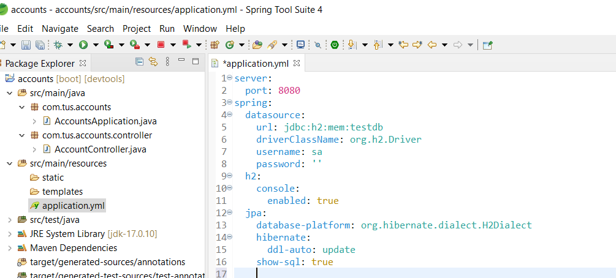

2. Create a file called scheme.sql (provided) in the resources folder with the following data.

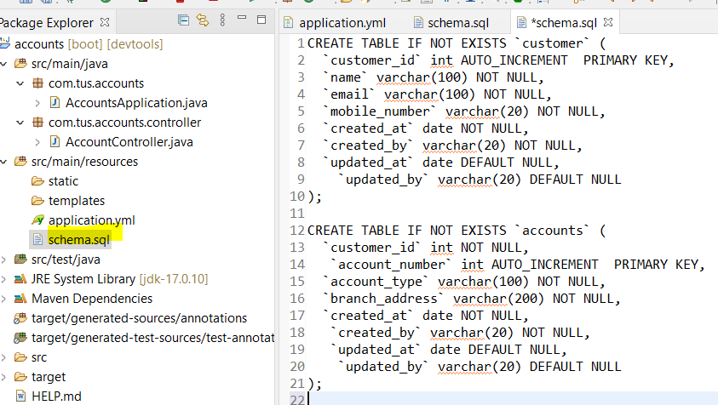

3. Restart the server. It will start on port 8080 based on yml file.

4. Go to the h2-console in the browser. You should see the two tables have bee created.

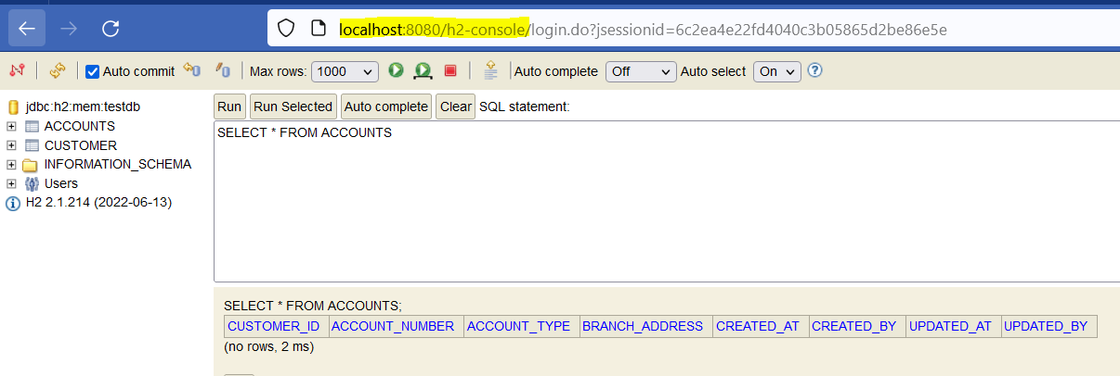

Now we will write Spring Data JPA entities & repositories to interact with DB tables

4. Create a new package for the entity classes as show below.

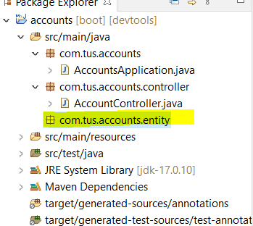

5. Add the classes BaseEntity, Accounts and Customers (given) and examine the code.

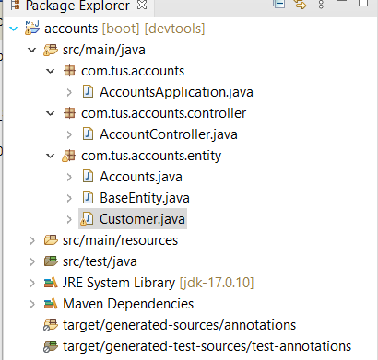

6. Now Add the Repository interfaces

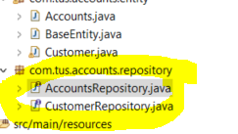

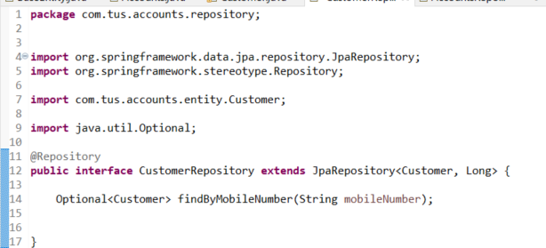

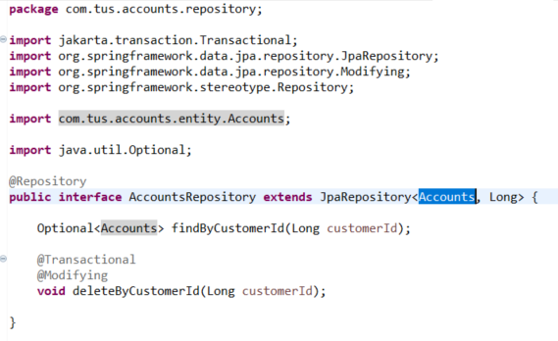

We will use the Data Transfer Object pattern to transfer data – not the entity classes themselves.

7. Create a new package with class AccountsDto and CustomerDto. These classes uses Lombok (You may need to turn on annotations in your IDE or install a Lombok jar)

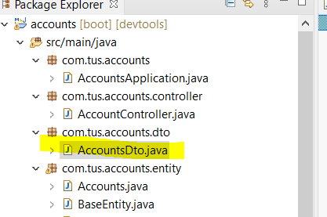

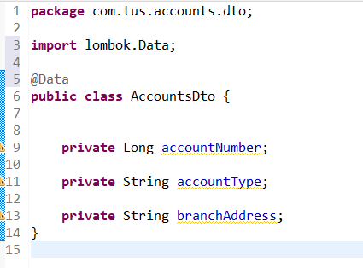

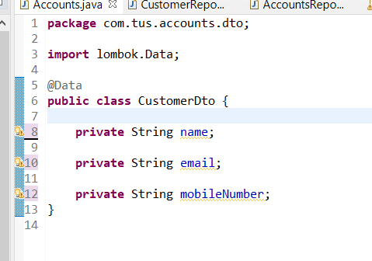

8. Also add a ResponseDto and an ErrorResponseDto class

